Compiling:

nasm hello.asm -f elf64 -o hello.o

Print to binary:

objdump -d hello.o | grep -Po '\s\K[a-f0-9]{2}(?=\s)' | sed 's/^/\\x/g' | perl -pe 's/\r?\n//' | sed 's/$/\n/'

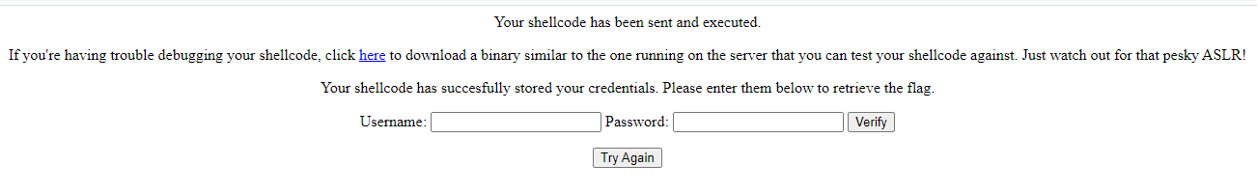

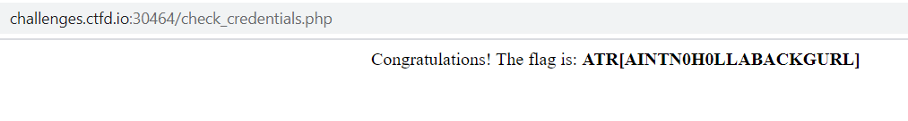

ASM Code:

SECTION .text

global main

main:

db 0xcc

push rbp

mov rbp, rsp

sub rsp, 8

mov rax, 0x5555555551b5

push 0x41414141

mov rdi, rsp

push 0x42424242

mov rsi, rsp

call rax

mov rsp, rbp

pop rbp

ret